Միևնույն կարգի գործողություններ պարունակող արտահայտություններ

Դասարանական և տնային առաջադրանքներ
Գումարումն ու հանումը միևնույն կարգի գործողություններ են։
Բազմապատկումն ու բաժանումը նույնպես միևնույն կարգի գործողություններ են։
Բազմապատկումն ու բաժանումը ավելի բարձր կարգի գործողություններ են համարվում, քան գումարումն ու հանումը։
Միևնույն կարգի գործողությունների կատարման կարգը․
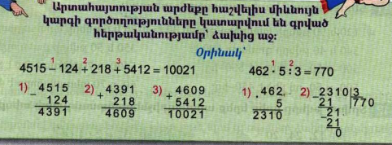

Հաշվի՛ր
2184-725+96542-7205=90796
 |  | 2 | `1 | 8 | `4
1) |  | - | 7 | 2 | 5 |  |  |  |  |  | 2) | - | 9 | `6 | 5 | 4 | `2
 |  | 1 | 4 | 5 | 9 |  |  |  |  |  |  |  |  | 7 | 2 | 0 | 5
 |  |  |  |  |  |  |  |  |  |  |  |  | 8 | 9 | 3 | 3 | 7
 |  |  | 3) | + | 8 | 9 | 3 | 3 | 7
 |  |  |  |  |  | 1 | 4 | 5 | 9
 |  |  |  |  | 9 | 0 | 7 | 9 | 6

8592-657+124567-7025=125477
 | - | 8 | `5 | 9 | `2 |  |  |  |  |  |  |  |  | 1 | 2 | `4 | 5 | 6 | 7
 |  |  | 6 | 5 | 7 |  |  |  |  |  |  |  |  |  |  | 7 | 0 | 2 | 5
 |  | 7 | 9 | 3 | 5 |  |  |  |  |  |  |  |  | 1 | 1 | 7 | 5 | 4 | 2
 |  |  |  |  |  |  | 1 | 1 | 7 | 5 | 4 | 2
 |  |  |  |  |  |  |  |  | 7 | 9 | 3 | 5
 |  |  |  |  |  |  | 1 | 2 | 5 | 4 | 7 | 7

5100:6$∙$40:200=170
 |  | 5 | `1 | 0 | 0 | 6 |  |  |  |  |  |  | x | 8 | 5 | 0
 |  | 4 | 8 |  |  | 8 | 5 | 0 |  |  |  |  |  |  | 4 | 0
 |  |  | 3 | 0 |  |  |  |  |  |  |  | 3 | 4 | 0 | 0 | 0
 |  |  | 3 | 0
 |  |  |  | 0
 |  |  |  |  |  | 3 | 4 | 0 | 0 | 0 | 2 | 0 | 0
 |  |  |  |  | -
 |  |  |  |  |  | 2 | 0 | 0 |  |  | 1 | 7 | 0
 |  |  |  |  |  | 1 | 4 | 0 | 0

